10/31/2023

A P, ARJUN

RBS, Amazon EU

**Advanced SQL**

**Final Project**

**TASK 1**

**Academic Management System.  
  
1. Database Creation:**  
**2. Table Creation:**

create table StudentInfo

(STU_ID int, STU_NAME varchar(100),

DOB DATE, PHONE_NO VARCHAR(10),EMAIL_ID varchar(50),

ADDRESS varchar(250),primary key (STU_ID));

create table CourseInfo

(COURSE_ID INT ,COURSE_NAME VARCHAR(100), COURSE_INSTRUCTOR_NAME VARCHAR(100), primary key (COURSE_ID));

create table EnrollmentInfo

(ENROLLMENT_ID INT, STU_ID int, COURSE_ID INT, ENROLL_STATUS varchar(20),

primary key (ENROLLMENT_ID),

FOREIGN KEY (STU_ID) REFERENCES StudentInfo(STU_ID),

FOREIGN KEY (COURSE_ID) REFERENCES CourseInfo(COURSE_ID));

create database student_database;

**Insert Values to the table:**

Insert Into StudentInfo

(STU_ID, STU_NAME, DOB, PHONE_NO, EMAIL_ID, ADDRESS) Values

('101', 'Arjun', '1993-08-23',9999999991, 'arjun@gmail.com', 'Bangalore'),

('102', 'Avinash', '1991-08-23',9999999992, 'avinash@gmail.com', 'Bangalore'),

('103', 'Rohan', '1998-08-25',9999999993, 'rohan@gmail.com', 'Chennai'),

('104', 'Samyugtha', '2000-10-23',9999999994, 'samyugtha@gmail.com', 'Mumbai'),

('105', 'Sneha', '2001-06-14',9999999995, 'sneha@gmail.com', 'Delhi'),

('106', 'Poornima', '1996-07-17',9999999996, 'poornima@gmail.com', 'Kochi');

Insert Into CourseInfo(COURSE_ID,COURSE_NAME, COURSE_INSTRUCTOR_NAME) values

(001, 'SQL', 'Ram'),

(002, 'Python', 'Sita'),

(003, 'AWS', 'Radha'),

(004, 'JAVA', 'Krishna'),

(005, 'CSS', 'Shiva');

insert into EnrollmentInfo(ENROLLMENT_ID, STU_ID, COURSE_ID, ENROLL_STATUS) values

(10001, 101, 001,'ENROLLED'),

(10002, 103, 002,'ENROLLED'),

(10003, 104, 004,'ENROLLED'),

(10004, 102, 003,'ENROLLED'),

(10005, 105, 003,'NOT ENROLLED'),

(10006, 106, 005,'ENROLLED'),

(10007, 101, 002,'ENROLLED');  
  
Select * From StudentInfo;

Select * From CourseInfo;

Select * From EnrollmentInfo;

**3. Retrieve the Student Information:**a) Write a query to retrieve Student details, Such as Student Name, Contact Information and Enrollment Status.  
  
Select StudentInfo.STU_NAME, StudentInfo.PHONE_NO, StudentInfo.ADDRESS,

ENROLL_STATUS

from StudentInfo , EnrollmentInfo

where StudentInfo.STU_ID=EnrollmentInfo.STU_ID order by ENROLL_STATUS ASC;  
  
OUTPUT:  
  
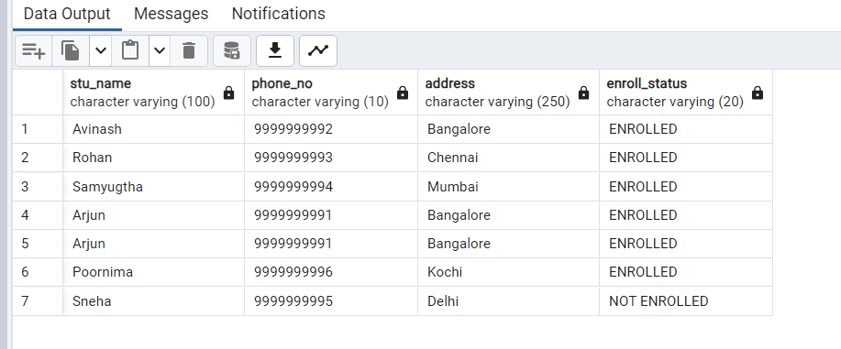b) Write a query to retrieve a list of courses in which a specific student enrolled.  
  
select c.COURSE_NAME, s.STU_NAME

from EnrollmentInfo e join CourseInfo c on e.course_id = c.course_id

join StudentInfo s on s.STU_ID = e.STU_ID;

OUTPUT:  
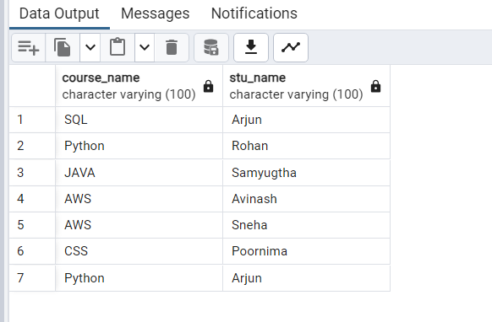

c) Write a query to retrieve course information, including course name insturctor information.

Select * From CourseInfo;  
  
OUTPUT:   
  
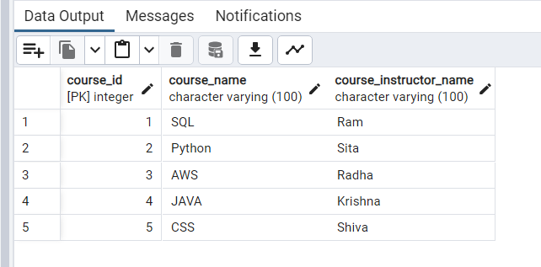

d) Write a query to retrieve course information for a specific course.  
  
Select COURSE_ID, COURSE_NAME, COURSE_INSTRUCTOR_NAME

from CourseInfo where COURSE_NAME='SQL';

OUTPUT:

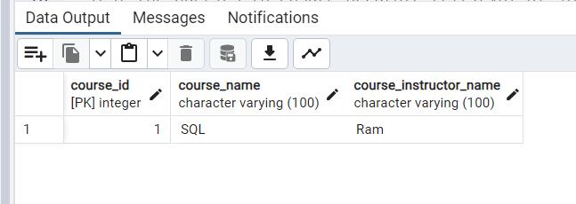

e) Write a query to retrieve course information for multiple courses.  
  
Select COURSE_ID, COURSE_NAME, COURSE_INSTRUCTOR_NAME

from CourseInfo where COURSE_NAME in ('SQL','Python');  
  
OUTPUT:

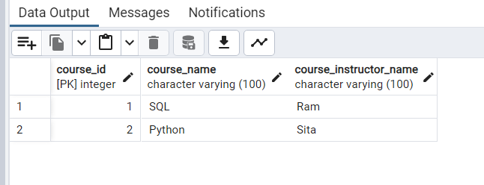

f) Test the queries to ensure accurate retrieval of Student Information.

(Execute queries and verify the results against the expected output).

Select * From StudentInfo;  
  
OUTPUT:  
  
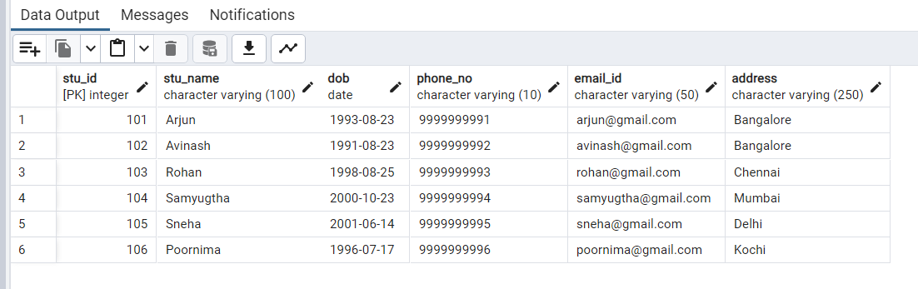

**4. Reporting and Analytics (using joining queries):**

a) Write a query to retrieve the number of students enrolled in each courses.

Select c.Course_Name , count(c.course_id) as numberofStud

from CourseInfo c join EnrollmentInfo e

on c.course_id=e.course_ID

where e.enroll_status = 'ENROLLED'

group by 1;

OUTPUT:

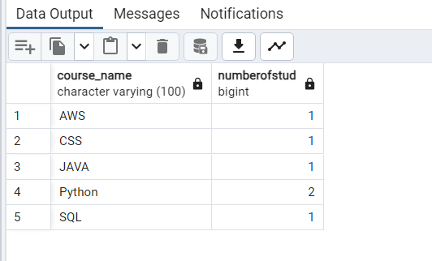

b) Write a query to retrieve the list of students enrolled in specific courses.  
  
select e.COURSE_ID, c.COURSE_NAME, s.STU_NAME

from CourseInfo c join EnrollmentInfo e on c.course_id=e.course_ID

join StudentInfo s on s.STU_ID = e.STU_ID where e.enroll_status = 'ENROLLED';

OUTPUT:

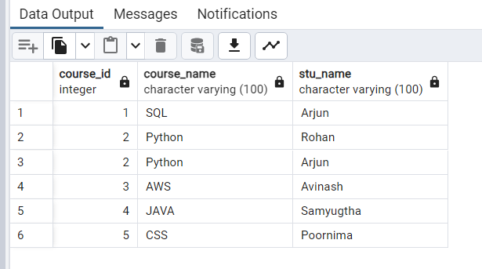

c) Write a query to retrieve the count of enrolled students for each instructor.  
  
Select c.COURSE_INSTRUCTOR_NAME , count(s.STU_ID) as numberofStud

from CourseInfo c join EnrollmentInfo e

on c.course_id=e.course_ID

join StudentInfo s on s.STU_ID = e.STU_ID

where e.enroll_status = 'ENROLLED'

group by 1;  
  
OUTPUT:

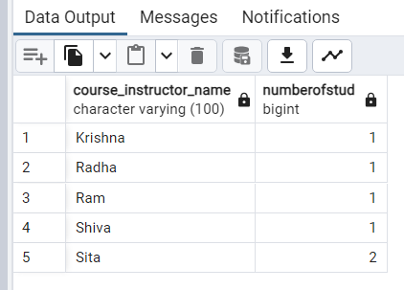

d) Write a query to retrieve the list of students who enrolled in multiple courses.  
  
Select S.STU_Name , count(c.course_id) as Number_of_courses

from CourseInfo c join EnrollmentInfo e

on c.course_id=e.course_ID

join StudentInfo s on s.STU_ID = e.STU_ID

where e.enroll_status = 'ENROLLED' group by 1 having count(c.course_name) >1;  
  
OUTPUT:

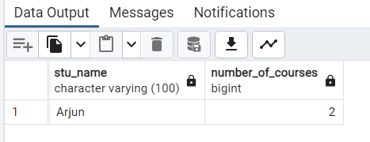

e) Write a query to retrieve the courses that have the highest number of enrolled students. (arrange from highest to lowest).  
  
Select S.STU_Name , count(c.course_id) as Number_of_courses

from CourseInfo c join EnrollmentInfo e

on c.course_id=e.course_ID

join StudentInfo s on s.STU_ID = e.STU_ID

where e.enroll_status = 'ENROLLED' group by 1 having count(c.course_name) >1

order by count(c.course_id) desc;  
  
OUTPUT:



**TASK 2**

**Student Database Management System:  
  
1) Database setup:  
  
a) Database creation.**CREATE DATABASE "Student_Database"

WITH

OWNER = postgres

ENCODING = 'UTF8'

LC_COLLATE = 'English_United States.1252'

LC_CTYPE = 'English_United States.1252'

TABLESPACE = pg_default

CONNECTION LIMIT = -1

IS_TEMPLATE = False;  
  
**a) Student table creation:**create table Student_table

(Student_id int, Stu_name varchar(100),

Department varchar(50), email_id varchar(50),

Phone_no numeric, Address varchar(250),

Date_Of_Birth DATE, Gender Varchar(30),

Major Varchar(50), GPA numeric, Grade varchar(10));

**2) Data Entry:**Insert into Student_table

(Student_id, Stu_name, Department, email_id, Phone_no, Address

,Date_Of_Birth, Gender, Major, GPA, Grade) Values

('1', 'Arjun A P', 'Engineering', 'arjun@gmail.com', '9999999991',

'Bangalore', '1999-04-26', 'Male', 'Computer Science', '8.8', 'A'),

('2', 'Avinash Murali', 'Arts and Sciences', 'avinash@gmail.com',

'9999999992', 'Chennai', '1992-07-15', 'Male', 'Mathematics', '8.6', 'A'),

('3', 'Rohan Shetty', 'Business', 'rohan@gmail.com', '9999999993',

'Mangalore', '1995-06-28', 'Male', 'MBA', '8.5', 'A'),

('4', 'Samyugtha C K', 'Arts and Sciences', 'samyugtha@gmail.com',

'9999999994', 'Chennai', '1997-01-12', 'Female', 'Physics', '7.6', 'B'),

('5', 'Sneha Sasi', 'Arts and communication', 'sneha@gmail.com',

'9999999995', 'Mumbai', '1995-10-26', 'Female', 'Communication', '6.9', 'B'),

('6', 'Poornima B', 'Engineering', 'poornima@gmail.com',

'9999999996', 'Goa', '2000-01-03', 'Female', 'Computer Science', '5.5', 'C'),

('7', 'Raghava V J', 'Human Development', 'raghava@gmail.com',

'9999999997', 'Uttar Pradesh', '2000-10-05', 'Male', 'Counseling', '7.0', 'B'),

('8', 'Parul Arora', 'Arts and communication', 'parul@gmail.com',

'9999999998', 'Gujarat', '1999-11-16', 'Female', 'Theatre', '9.2', 'A'),

('9', 'Naveen Kumar', 'Business', 'naveen@gmail.com', '9999999999',

'Rajasthan', '2003-08-14', 'Male', 'Accounting', '7.9', 'B'),

('10', 'Ritu Prasad', 'Arts and Sciences', 'ritu@gmail.com',

'9999999911', 'Mumbai', '1997-03-12', 'Male', 'Physics', '4.9', 'C');

**3) Student information retrieval:**Select * from Student_table

Order By GPA desc, Grade;  
  
OUTPUT:

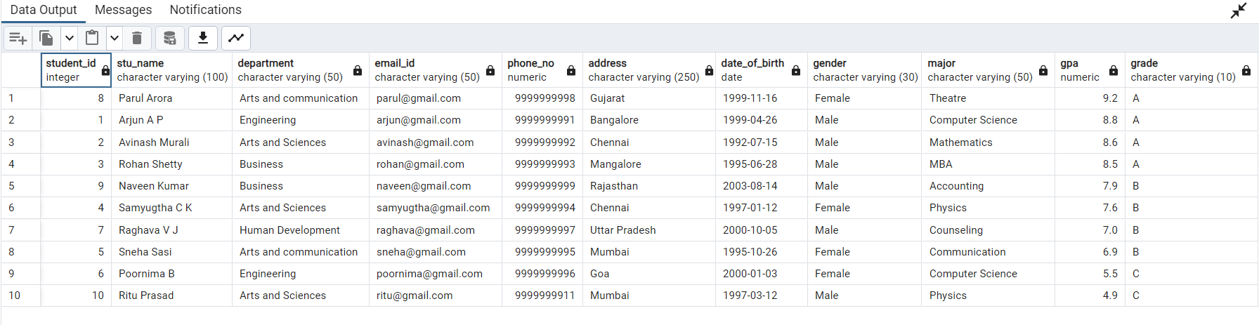

**4) Query for Male students:**Select * from Student_table

where Gender = 'Male';

OUTPUT:

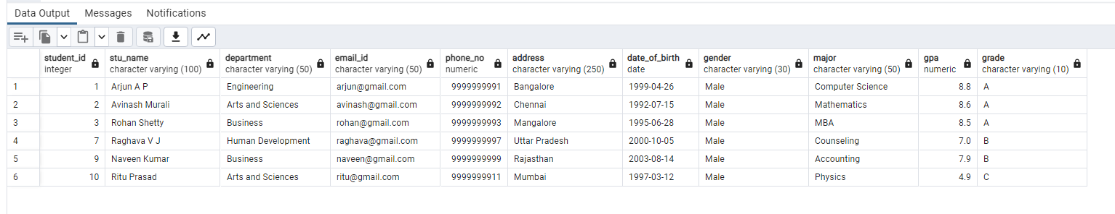  
  
  
**5) GPA less than 5:**  
Select * from Student_table

where GPA <5.0;

OUTPUT:

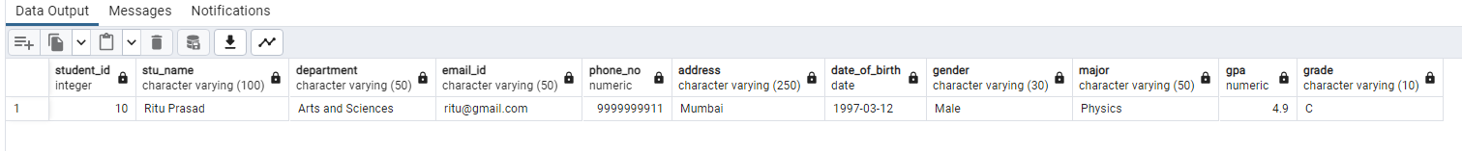

**6) Update email_id and Grade:**UPDATE Student_table

SET email_id = 'ritu123@gmail.com', GPA='3.0', Grade = 'D'

Where Student_id = '10';

**7) Query Grade B:**SELECT Stu_name, date_part('year',age(Date_Of_Birth)) as Age

FROM Student_table

Where Grade = 'B';  
  
OUTPUT:

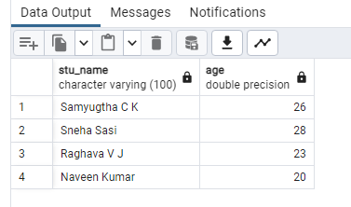

**8) Grouping and calculation:**Select Department, Gender, round(Avg(GPA),2) as Avg_GPA

From Student_table

Group By 1,2 Order By Avg(GPA) DESC;  
  
OUTPUT:

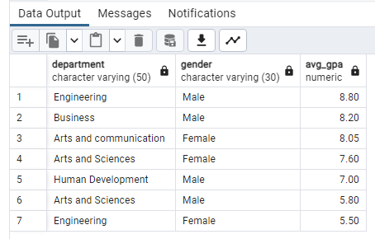

**9) Table Renaming:**

Alter table Student_table

Rename to Student_info;

Select * from Student_info;

OUTPUT:  
  
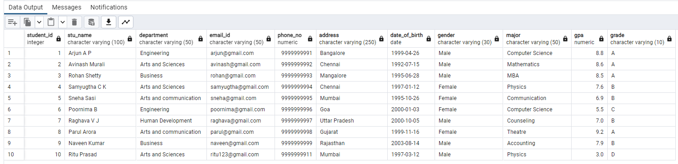

**10) Retrieve student with highest GPA:**Select Stu_name, GPA

From Student_info where GPA = (Select Max(GPA) From Student_info);

OUTPUT:  
  
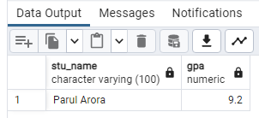

**TASK 3**

**Event management system using PostgreSQL.  
  
1) Database creation:**CREATE DATABASE "EventsManagement"

WITH OWNER = postgres ENCODING = 'UTF8'

LC_COLLATE = 'English_United States.1252'

LC_CTYPE = 'English_United States.1252'

TABLESPACE = pg_default

CONNECTION LIMIT = -1

IS_TEMPLATE = False;  
  
**a) Table creation:**Create table Events (Event_Id Int, Event_Name Varchar(30), Event_Date Date,

Event_Location Varchar(100), Event_Description Varchar(200), primary key (Event_Id));

Create table Attendees (Attendee_Id Int, Attendee_Name Varchar(30),

Attendee_Phone numeric, Attendee_Email Varchar(30), Attendee_City Varchar(20),

primary key (Attendee_Id));

Create table Registrations (Registration_Id Int, Event_Id Int, Attendee_Id Int,

Registration_Date Date, Registration_Amount numeric, primary key (Registration_Id),

FOREIGN KEY (Event_Id) REFERENCES Events(Event_Id),

FOREIGN KEY (Attendee_Id) REFERENCES Attendees(Attendee_Id));

**2) Data creation:**insert into Events (Event_Id, Event_Name, Event_Date, Event_Location, Event_Description) values

('101', 'BTS', '2024-01-01', 'Bangalore', 'Music Show'),

('102', 'G20 Summit', '2023-09-09', 'Delhi', 'Conference'),

('103', 'Sunburn', '2023-12-31', 'Goa', 'Music Show'),

('104', 'Jellikettu', '2024-01-15', 'Madura', 'Festival'),

('105', 'Stand up Comedy', '2024-02-13', 'Kolkata', 'Comedy');

Select * from Events;OUTPUT:  
  
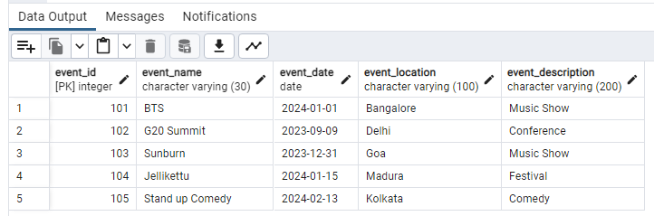Insert into Attendees (Attendee_Id, Attendee_Name, Attendee_Phone, Attendee_Email, Attendee_City) values

('1001', 'Arjun', '9999999991', 'arjun@gmail.com', 'Bangalore'),

('1002', 'Avinash', '9999999992', 'avinash@gmail.com', 'Chennai'),

('1003', 'Samyugtha', '9999999993', 'samyugtha@gmail.com', 'Chennai'),

('1004', 'Poornima', '9999999994', 'poornima@gmail.com', 'Goa'),

('1005', 'Rohan', '9999999995', 'rohan@gmail.com', 'Mangalore'),

('1006', 'Sneha', '9999999996', 'sneha@gmail.com', 'Mumbai'),

('1007', 'Raghava', '9999999997', 'raghava@gmail.com', 'Vijayawada'),

('1008', 'Naveen', '9999999998', 'naveen@gmail.com', 'Delhi');

Select * from Attendees;  
  
OUTPUT:  
  
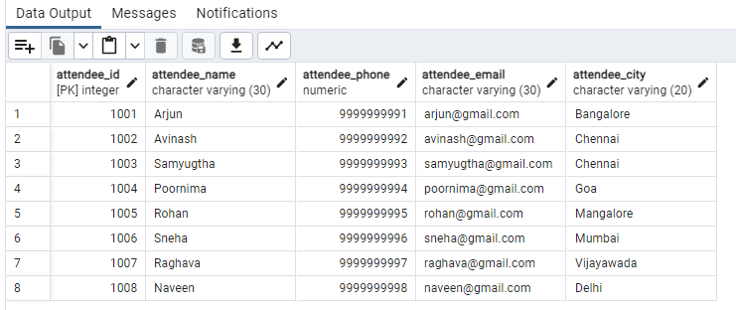

Insert into Registrations

(Registration_Id, Event_Id, Attendee_Id, Registration_Date, Registration_Amount) values

('10001', '101', '1001', '2023-11-30', '7500'),

('10002', '102', '1003', '2023-09-01', '1000'),

('10003', '103', '1002', '2023-12-12', '2000'),

('10004', '104', '1004', '2023-11-25', '500'),

('10005', '101', '1005', '2023-12-10', '7500'),

('10006', '103', '1008', '2023-11-30', '2000'),

('10007', '101', '1007', '2023-11-15', '7500'),

('10008', '102', '1006', '2023-09-01', '1000');

Select *from Registrations;

OUTPUT:

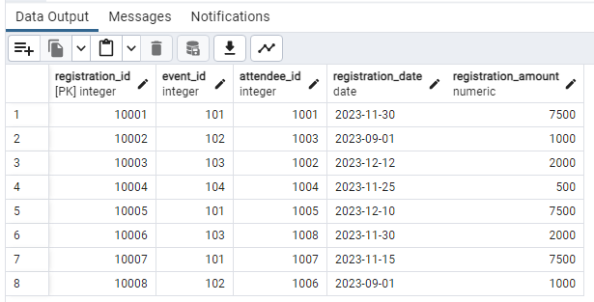

**3) Manage Event Details  
  
a) Insert New event:**

Insert INTO Events (Event_Id, Event_Name, Event_Date, Event_Location, Event_Description) VALUES

('106', 'Cricket World cup Final', '2023-10-19', 'Ahmedabad', 'ICC World Cup');

Select * from Events where Event_Id = '106';  
  
OUTPUT:  
  
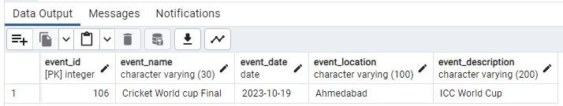

**b) Updating an event's information:**UPDATE Events

SET Event_Location = 'Bangalore' Where Event_Id = '105';

Select * from Events where Event_Id = '105';  
  
OUTPUT:  
  
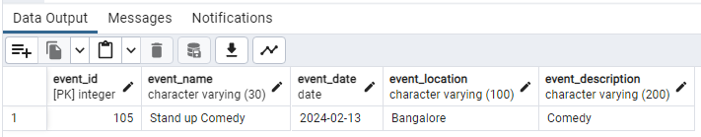

**c) Deleting an event:**Delete from Events where Event_Id = '106';

Select * from Events;  
  
OUTPUT:  
  
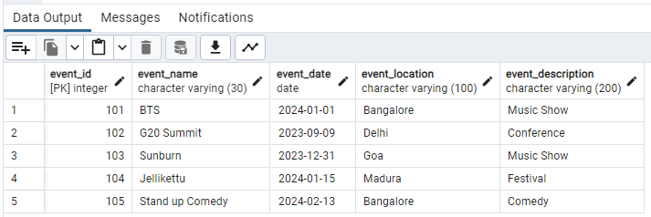

**4) Manage Event Details  
  
a) Insert new attendee:**Insert into Attendees (Attendee_Id, Attendee_Name, Attendee_Phone, Attendee_Email, Attendee_City)

values ('1009', 'Ashish', '9999999999', 'ashish@gmail.com', 'Jaipur');

Select * from Attendees where Attendee_Id = '1009';  
  
OUTPUT:  
  
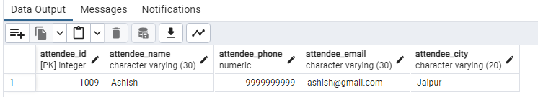

**b) Registering an attendee of an event:**Insert into Registrations (Registration_Id, Event_Id, Attendee_Id, Registration_Date, Registration_Amount)

values ('10009', '101', '1009', '2023-11-15', '7500');

Select * from Registrations where Registration_Id = '10009';  
  
OUTPUT:  
  
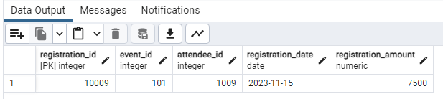

**5) Develop the queries to retrieve event information, generate attendee lists and calculate event attendance statistics.**

with Event1 as(

select E.Event_id, E.event_name, E.event_date, E.event_location,  
 count(R.Event_Id) over(partition by R.Event_Id) as NumberofAttendees,

sum(R.registration_amount) over(partition by E.event_id) as Amountgenperevent

from Events E join Registrations R on E.event_id = R.event_id

join Attendees A on A.attendee_id = R.attendee_id)

select Event_id, event_name, event_location, Amountgenperevent , NumberofAttendees

from Event1 group by 1,2,3,4,5;  
OUTPUT:  
  
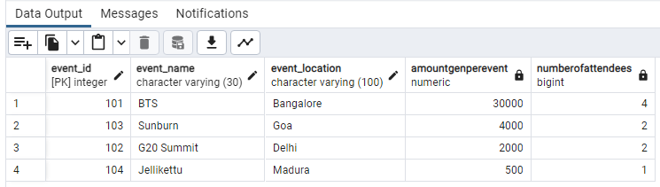

**TASK 4**

**OLAP operations using PostgreSQL.  
  
1) Database creation:**CREATE DATABASE "Sales Data";

WITH OWNER = postgres

ENCODING = 'UTF8'

LC_COLLATE = 'English_United States.1252'

LC_CTYPE = 'English_United States.1252'

TABLESPACE = pg_default

CONNECTION LIMIT = -1

IS_TEMPLATE = False; **a) Table creation:** Create table Sales_sample (Product_Id Int, Region Varchar(50), On_date Date,

Sales_Amount Numeric);  
 **2) Data creation:**Insert into Sales_sample (Product_Id, Region, On_date, Sales_Amount) values

('1', 'Kolkata', '2023-10-10', '20000'),

('2', 'Ahmedabad', '2023-09-19', '50000'),

('2', 'Kolkata', '2023-10-21', '40000'),

('3', 'Delhi', '2023-09-20', '15000'),

('4', 'Delhi', '2023-08-06', '45000'),

('2', 'Chennai', '2023-08-25', '45000'),

('5', 'Delhi', '2023-11-23', '20000'),

('5', 'Ahmedabad', '2023-11-11', '60000'),

('3', 'Kolkata', '2023-09-19', '50000'),

('1', 'Ahmedabad', '2023-09-29', '70000');

Select * from Sales_Sample;  
  
OUTPUT:  
  
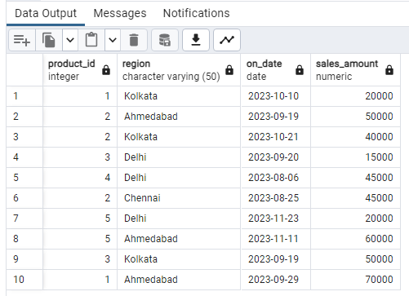

**3) Perform OLAP operations:  
  
a) Drill Down:**Select Region, Product_Id, Sum(Sales_Amount) as Sales_Amount

From Sales_Sample

Group By 1,2 Order By Region, Product_Id, Sales_Amount;

OUTPUT:

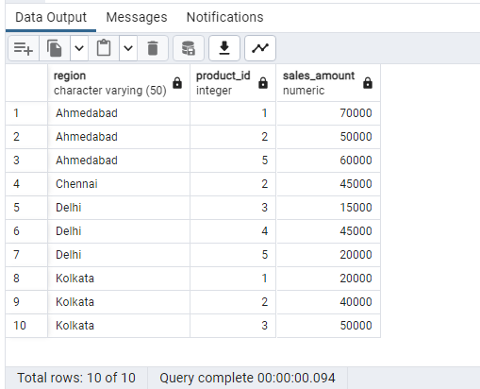

**b) Roll up:**Select Region, Product_Id, Sum(Sales_Amount) as Sales_Amount

From Sales_Sample

Group By Rollup (2,1)

Order By Region;

OUTPUT:

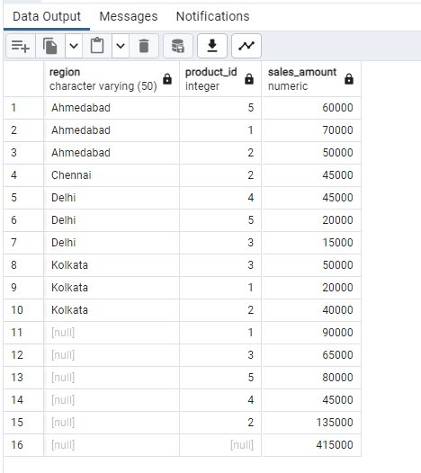

**c) Cube:**Select Region, Product_Id, On_Date, Sum(Sales_Amount) as Sales_Amount

From Sales_Sample

Group By Cube (1,2,3)

Order By Region, Product_Id, On_Date, Sales_Amount;

OUTPUT:  
  
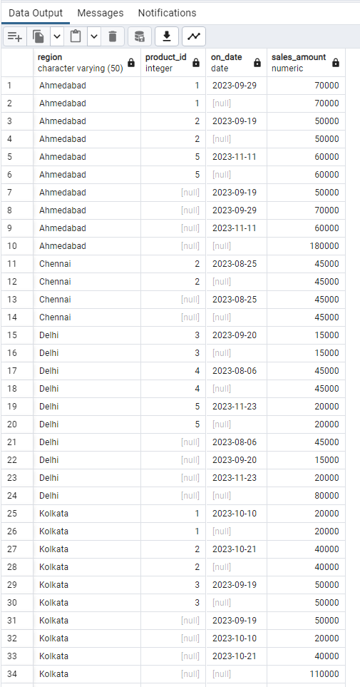  
**d) Slice:**Select Region, Product_Id, On_Date, Sum(Sales_Amount) as Sales_Amount From Sales_Sample

Where Region in('Delhi', 'Chennai') OR On_Date between To_date('2023-08-20','YYYY-MM-DD') And To_Date('2023-10-20','YYYY-MM-DD')

Group By 1,2,3 Order By Region, Product_Id, On_Date, Sales_Amount;

OUTPUT:  
  
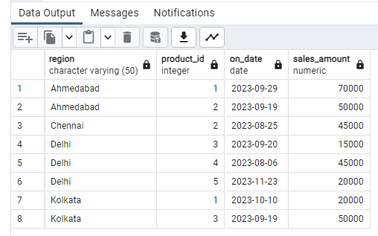

**e) Dice:**Select Region, Product_Id, On_Date, Sum(Sales_Amount) as Sales_Amount

From Sales_Sample Where Region in('Delhi', 'Chennai') AND Product_Id IN (1,2) AND On_Date between To_date('2023-08-20','YYYY-MM-DD') And To_Date('2023-10-20','YYYY-MM-DD')

Group By 1,2,3 Order By Region, Product_Id, On_Date, Sales_Amount;  
OUTPUT: